ParkinsonSAT Electrical Power System

Introduction

The electrical power system on ParkinsonSAT distributes power from the solar cells and batteries to the various loads at the correct voltages and in such a manner that faults in the loads will not bring the entire system down. The electrical power system also provides for using solar cells to charge each battery.

Solar Power System

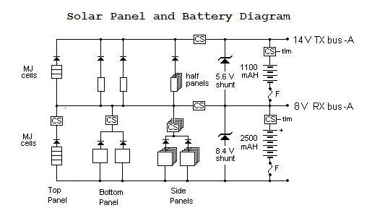
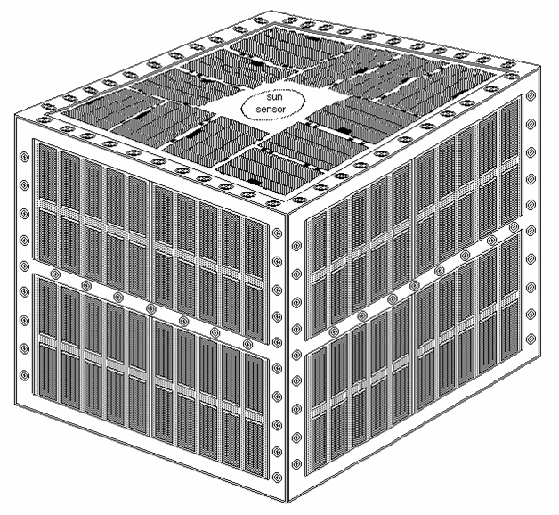
The solar panels on ParkinsonSAT provide the necessary power to operate the spacecraft and to charge the batteries. Figure 1 shows the arrangement of the solar panels on each of the four sides as well as the top of the spacecraft. Figure 2 shows a schematic of how each side of the system will be wired together. Each side face will have separate power circuits for the A and B systems of the spacecraft. Each A/B system will have two full panels wired in parallel to generate the proper voltage for the 8v bus, and will be wired in series with one half panel to generate the rest of the voltage necessary to create the 14v bus. The bottom face will also have A and B systems consisting of two full solar panels in parallel providing power to the 8v bus a nd those will be wired in series with two half panels, wired in parallel, to provide the additional voltage for the 14v bus. The top face will use the high-cost solar cells. It will have, similarly, A and B strings consisting of 4 solar cells which will be wired in series for the 8v bus and 3 solar cells to provide the added voltage for the 14v bus.
Figure 1: Physical Solar Panel Diagram

Figure 2: Side A EPS (B is similar)

Battery System

The battery system on ParkinsonSAT is composed of two banks, an A and B set, of batteries, each divided into two strings of cells. The separate banks allow for redundant busses to distribute power to the loads. The battery cell strings in each bank allow both sides to have two buses of different voltages, one at 8 volts and another at 14 volts. The 8v buses consist of 6 cells wired in series. The 14v buses use an additional 4 cells.

Charging of the battery system from the solar panels is regulated via shunt regulators to prevent damaging the battery cells due to overcharging. Fuses are placed between the batteries and ground to prevent a short in a cell to the battery casing from generating a catastrophic hazard to both the battery and the spacecraft.

Loads

The table to the left gives a current list of the power requirements for the spacecraft. The power distribution system schematic is shown in Appendix A.

All loads with the exception of the transmitters operate from the 8v buses of both side A and side B. Diodes with a .5v drop keep each bus independent of faults on the other. Relays control the power availability to each load. The primary receivers, TNC modems and CPU system are always be powered. Fuses in series with each load, located electrically between the loads and the buses, prevent a fault in one load affecting the rest of the distribution system. The two transmitters are be powered from the 14v busses on both the A and B sides, with similar fuses and diodes to protect the system integrity. The transmitters operate in burst mode and are only powered when keyed by the TNCs.

All loads can be powered from one side of the system alone; it is not necessary for both sides of the electrical power system to be operable for the loads to receive power. The batteries are designed to operate 30 minutes in eclipse while running under full load and remaining above a 20% depth of discharge.
Table 1: Worldwide User Density
Country | Pass/Day | Transponder Load Density | Weighted PPD | Min/Pass | Total Minutes
W-USA | 6 | 1 | 6 | 20 | 120
E-USA | 6 | 1 | 6 | 20 | 120
W-EU | 6 | 1 | 6 | 15 | 90
E-EU | 6 | 0.7 | 4 | 15 | 60
NZ | 6 | 0.5 | 3 | 15 | 45
Japan | 6 | 0.5 | 3 | 10 | 30
S. America | 6 | 0.3 | 2 | 10 | 20
S. Africa | 6 | 0.1 | 1 | 10 | 10
Hawaii | 6 | 0.1 | 1 | 10 | 10
Total |  |  |  |  | 505
Min/Day |  |  |  |  | 1440
Demand Load |  |  |  |  | 35%
To determine the average system load, duty cycles for each component must be determined. Transmitter duty cycle begins with determining the number of minutes per day the satellite is expected to be transmitting to users. This is given in table 1. This is then combined with the other transmission packets (telemetry, beacons and bulletins) to determine the length of time the transmitter will be transmitting in an orbit. This is given in table 2.

Duty cycles for all other loads are assumed, and average currents can then be calculated to give an average required power, shown in table 3.

Table 2: Transmission Duty Cycle
Data | Pkts/Min |  |  | Usage | Weighted Pkts/Min
Data | H | L | S | Usage
 |  |  |  |  | H | L | S
Telemtry | 6 | 1 | 1 | 100% | 6 | 1 | 1
Beacons | 1 | 0.2 | 0 | 100% | 1 | 0.2 | 0
Bulletins | 2 | 0.5 | 0 | 100% | 2 | 0.5 | 0
Users | 20 | 5 | 0 | 35% | 7 | 1.75 | 0
Total |  |  |  |  | 16 | 3.45 | 1
Duty Cycle |  |  |  |  | 27% | 6% | 2%

Table 3: PSAT Power Budget
 | Current (mA) | Duty Cycle |  |  | Avg (mA)
 | Current (mA) | H | L | S | H | L | S
VHF FM TX1 | 500 | 27% | 6% | 2% | 133 | 29 | 8
VHF FM TX2 | 500 | 27% | 6% | 2% | 133 | 29 | 8
VHF FM RX1 | 30 | 100% | 100% | 100% | 30 | 30 | 30
VHF FM RX2 | 30 | 100% | 100% | 100% | 30 | 30 | 30
VHF FM RX3 | 30 | 100% | 100% | 100% | 30 | 30 | 30
VHF FM RX4 | 30 | 100% | 100% | 100% | 30 | 30 | 30
TNC1 | 40 | 100% | 100% | 100% | 40 | 40 | 40
TNC2 | 40 | 100% | 100% | 100% | 40 | 40 | 40
10% Reserve |  |  |  |  | 47 | 26 | 22
Avg (mA) |  |  |  |  | 513 | 284 | 238
MiDn | 119 | 100% | 0% | 0% | 119 | 0 | 0
ODTML | 1200 | 100% | 0% | 0% | 1200 | 0 | 0
RFI | 50 | 100% | 0% | 0% | 50 | 0 | 0
ADCS | 500 | 20% | 10% | 5% | 100 | 50 | 25
10% Reserve (payloads) |  |  |  |  | 147 | 5 | 3
Avg (mA) |  |  |  |  | 2129 | 339 | 266

Eclipse and Available Power

Based on the current solar cell configuration, there will be an average of 10W per side of available power. This gives 1.25A at 8V for each side for a total of 2.5A from both sides. Assuming an altitude of 500km with a resulting eclipse time of 35.75 minutes, table 4 provides the amount of current available to charge the battery when the satellite is in daylight compared to various loadings. This table shows that the available power from the solar cells can provide for less than half of the design load requirements in table 3 while still providing current for battery charging.
Table 4: Charging Current Availability
Isa (mA) | Ie (mA) | Id (mA) | Id-Ie (mA)
2500 | 1000 | 1330.8774 | 330.8774
2500 | 1250 | 1132.3467 | -117.653
2500 | 1500 | 933.81604 | -566.184
2500 | 1750 | 735.28537 | -1014.71
2500 | 2000 | 536.75471 | -1463.25
2500 | 2250 | 338.22405 | -1911.78
2500 | 2500 | 139.69339 | -2360.31

